Week 3 - Spring Core and Maven

1.Spring Core_Maven

i) Configuring a Basic Spring Application:

pom.xml

<project xmlns="http://maven.apache.org/POM/4.0.0"

xmlns:xsi="http://www.w3.org/2001/XMLSchema-instance"

xsi:schemaLocation="http://maven.apache.org/POM/4.0.0

http://maven.apache.org/xsd/maven-4.0.0.xsd">

<modelVersion>4.0.0</modelVersion>

<groupId>com.library</groupId>

<artifactId>LibraryManagement</artifactId>

<version>1.0</version>

<dependencies>

<dependency>

<groupId>org.springframework</groupId>

<artifactId>spring-context</artifactId>

<version>5.3.34</version>

</dependency>

</dependencies>

</project>

applicationContext.xml

<?xml version="1.0" encoding="UTF-8"?>

<beans xmlns="http://www.springframework.org/schema/beans"

xmlns:xsi="http://www.w3.org/2001/XMLSchema-instance"

xsi:schemaLocation="http://www.springframework.org/schema/beans

http://www.springframework.org/schema/beans/spring-beans.xsd">

<bean id="bookRepository" class="com.library.repository.BookRepository"/>

<bean id="bookService" class="com.library.service.BookService">

<property name="bookRepository" ref="bookRepository"/>

</bean>

</beans>

BookRepository.java

package com.library.repository;

public class BookRepository {

public String getBookName() {

return "Effective Java";

}

}

BookService.java

package com.library.service;

import com.library.repository.BookRepository;

public class BookService {

private BookRepository bookRepository;

public void setBookRepository(BookRepository bookRepository) {

this.bookRepository = bookRepository;

}

public void displayBook() {

System.out.println("Book: " + bookRepository.getBookName());

}

}

MainApp.java

package com.library;

import com.library.service.BookService;

import org.springframework.context.ApplicationContext;

import org.springframework.context.support.ClassPathXmlApplicationContext;

public class MainApp {

public static void main(String[] args) {

ApplicationContext context = new ClassPathXmlApplicationContext("applicationContext.xml");

BookService service = (BookService) context.getBean("bookService");

service.displayBook();

}

}

Output:

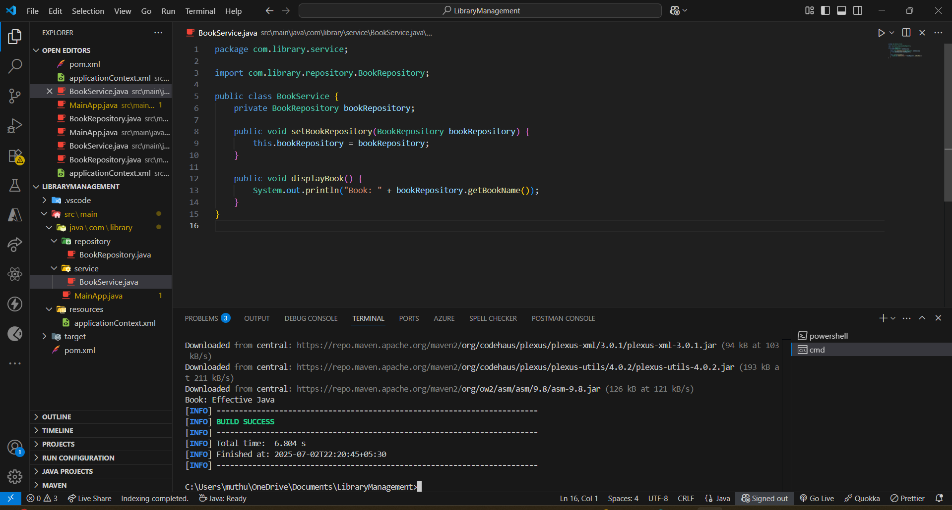

ii)Implementing Dependency Injection:

applicationContext.xml

<?xml version="1.0" encoding="UTF-8"?>

<beans xmlns="http://www.springframework.org/schema/beans"

xmlns:xsi="http://www.w3.org/2001/XMLSchema-instance"

xsi:schemaLocation="http://www.springframework.org/schema/beans

http://www.springframework.org/schema/beans/spring-beans.xsd">

<bean id="bookRepository" class="com.library.repository.BookRepository" />

<bean id="bookService" class="com.library.service.BookService">

<property name="bookRepository" ref="bookRepository" />

</bean>

</beans>

BookService.java

package com.library.service;

import com.library.repository.BookRepository;

public class BookService {

private BookRepository bookRepository;

public void setBookRepository(BookRepository bookRepository) {

this.bookRepository = bookRepository;

}

public void displayBook() {

System.out.println("Book: " + bookRepository.getBookName());

}

}

BookRepository.java

package com.library.repository;

public class BookRepository {

public String getBookName() {

return "Effective Java";

}

}

MainApp.java

package com.library;

import com.library.service.BookService;

import org.springframework.context.ApplicationContext;

import org.springframework.context.support.ClassPathXmlApplicationContext;

public class MainApp {

public static void main(String[] args) {

ApplicationContext context = new ClassPathXmlApplicationContext("applicationContext.xml");

BookService bookService = (BookService) context.getBean("bookService");

bookService.displayBook();

}

}

Output:

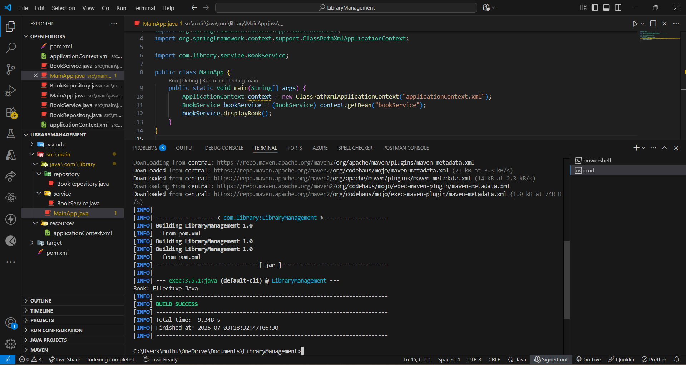

iii) Creating and Configuring a Maven Project:

pom.xml

<project xmlns="http://maven.apache.org/POM/4.0.0"

xmlns:xsi="http://www.w3.org/2001/XMLSchema-instance"

xsi:schemaLocation="http://maven.apache.org/POM/4.0.0

http://maven.apache.org/xsd/maven-4.0.0.xsd">

<modelVersion>4.0.0</modelVersion>

<groupId>com.library</groupId>

<artifactId>LibraryManagement</artifactId>

<version>1.0</version>

<dependencies>

<!-- Spring Context -->

<dependency>

<groupId>org.springframework</groupId>

<artifactId>spring-context</artifactId>

<version>5.3.34</version>

</dependency>

<!-- Spring AOP -->

<dependency>

<groupId>org.springframework</groupId>

<artifactId>spring-aop</artifactId>

<version>5.3.34</version>

</dependency>

<!-- Spring WebMVC -->

<dependency>

<groupId>org.springframework</groupId>

<artifactId>spring-webmvc</artifactId>

<version>5.3.34</version>

</dependency>

</dependencies>

<build>

<plugins>

<!-- Compiler Plugin -->

<plugin>

<artifactId>maven-compiler-plugin</artifactId>

<version>3.11.0</version>

<configuration>

<source>1.8</source>

<target>1.8</target>

</configuration>

</plugin>

<!-- Exec Plugin (for running Java main) -->

<plugin>

<groupId>org.codehaus.mojo</groupId>

<artifactId>exec-maven-plugin</artifactId>

<version>3.1.0</version>

<configuration>

<mainClass>com.library.MainApp</mainClass>

</configuration>

</plugin>

</plugins>

</build>

</project>

MainApp.java

package com.library;

public class MainApp {

public static void main(String[] args) {

System.out.println("✅ Spring Project Setup Successful!");

}

}

applicationContext.xml

<?xml version="1.0" encoding="UTF-8"?>

<beans xmlns="http://www.springframework.org/schema/beans"

xmlns:xsi="http://www.w3.org/2001/XMLSchema-instance"

xsi:schemaLocation="http://www.springframework.org/schema/beans

http://www.springframework.org/schema/beans/spring-beans.xsd">

</beans>

Output:

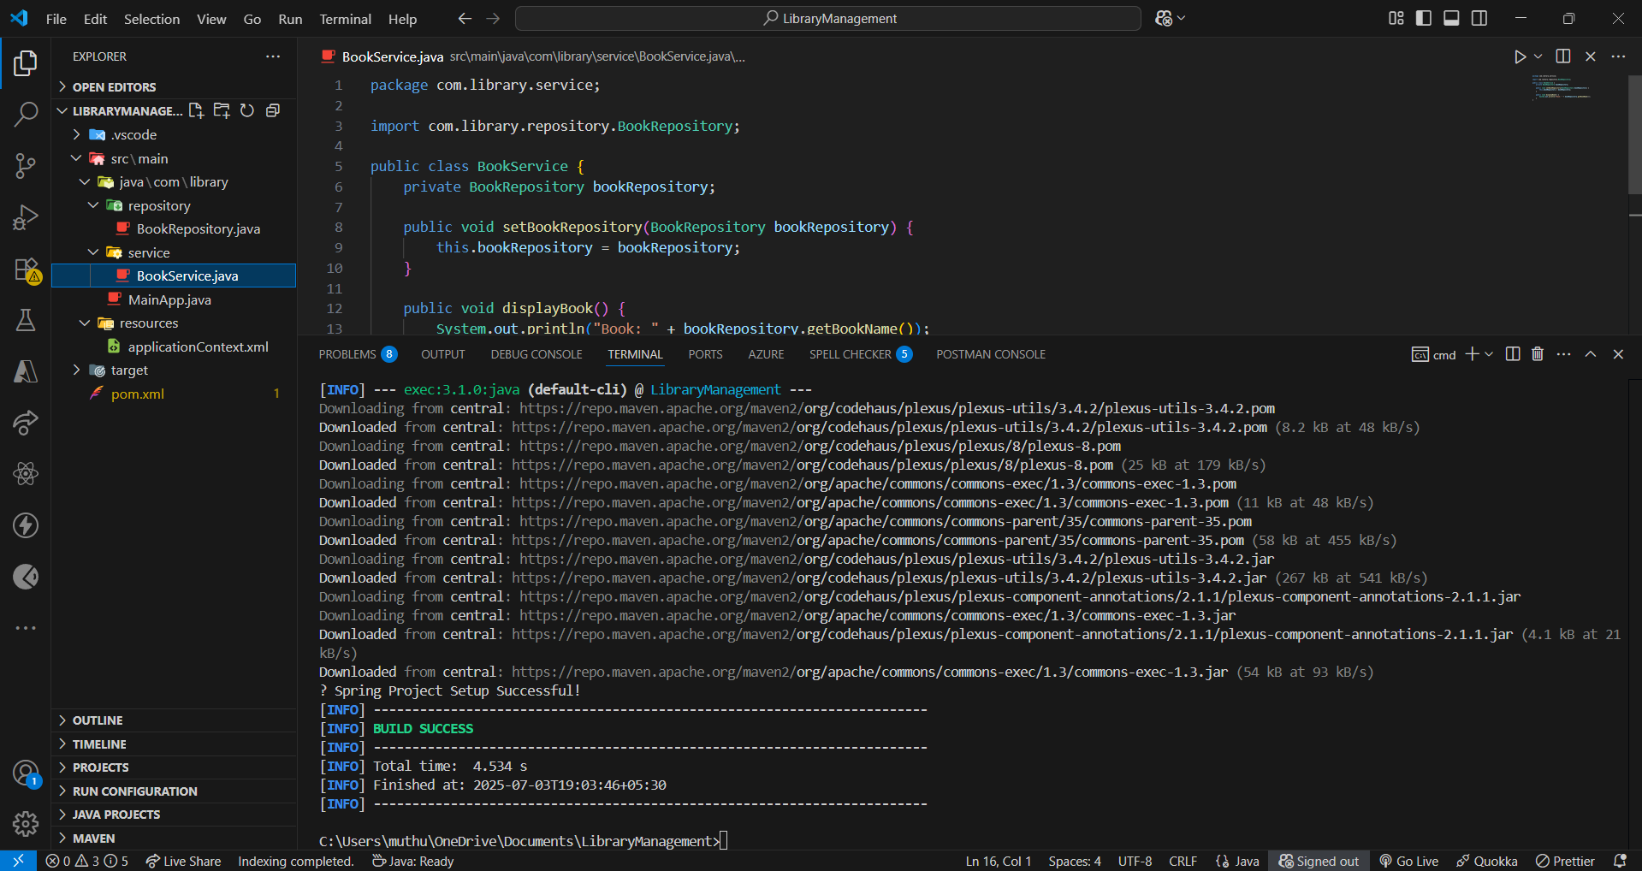

2.Spring Data JPA with Spring Boot, Hibernate

spring-data-jpa-handson

i)Spring Data JPA - Quick Example:

application.properties

# LOGGING

logging.level.org.springframework=info

logging.level.com.cognizant=debug

logging.level.org.hibernate.SQL=trace

logging.level.org.hibernate.type.descriptor.sql=trace

logging.pattern.console=%d{dd-MM-yy} %d{HH:mm:ss.SSS} %-20.20thread %5p %-25.25logger{25} %25M %4L %m%n

# DATASOURCE

spring.datasource.driver-class-name=com.mysql.cj.jdbc.Driver

spring.datasource.url=jdbc:mysql://localhost:3306/ormlearn

spring.datasource.username=root

spring.datasource.password=root

# HIBERNATE

spring.jpa.hibernate.ddl-auto=validate

spring.jpa.properties.hibernate.dialect=org.hibernate.dialect.MySQL5Dialect

Country.java

package com.cognizant.ormlearn.model;

import javax.persistence.Column;

import javax.persistence.Entity;

import javax.persistence.Id;

import javax.persistence.Table;

@Entity

@Table(name = "country")

public class Country {

@Id

@Column(name = "co_code")

private String code;

@Column(name = "co_name")

private String name;

// getters, setters, toString()

public String getCode() { return code; }

public void setCode(String code) { this.code = code; }

public String getName() { return name; }

public void setName(String name) { this.name = name; }

@Override

public String toString() {

return "Country [code=" + code + ", name=" + name + "]";

}

}

CountryRepository.java

package com.cognizant.ormlearn.repository;

import org.springframework.data.jpa.repository.JpaRepository;

import org.springframework.stereotype.Repository;

import com.cognizant.ormlearn.model.Country;

@Repository

public interface CountryRepository extends JpaRepository<Country, String> { }

OrmLearnApplication.java

package com.cognizant.ormlearn;

import java.util.List;

import org.slf4j.Logger;

import org.slf4j.LoggerFactory;

import org.springframework.boot.SpringApplication;

import org.springframework.boot.autoconfigure.SpringBootApplication;

import org.springframework.context.ApplicationContext;

import com.cognizant.ormlearn.model.Country;

import com.cognizant.ormlearn.service.CountryService;

@SpringBootApplication

public class OrmLearnApplication {

private static final Logger LOGGER = LoggerFactory.getLogger(OrmLearnApplication.class);

private static CountryService countryService;

public static void main(String[] args) {

ApplicationContext context = SpringApplication.run(OrmLearnApplication.class, args);

countryService = context.getBean(CountryService.class);

LOGGER.info("Inside main");

testGetAllCountries();

}

private static void testGetAllCountries() {

LOGGER.info("Start");

List<Country> countries = countryService.getAllCountries();

LOGGER.debug("countries={}", countries);

LOGGER.info("End");

}

}

Output:

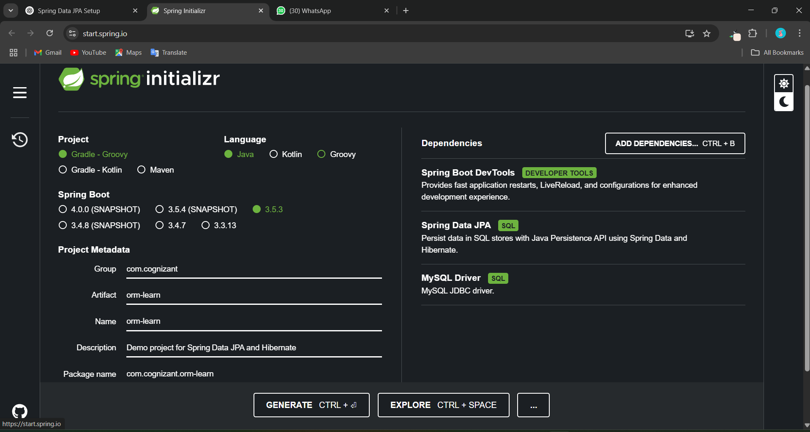

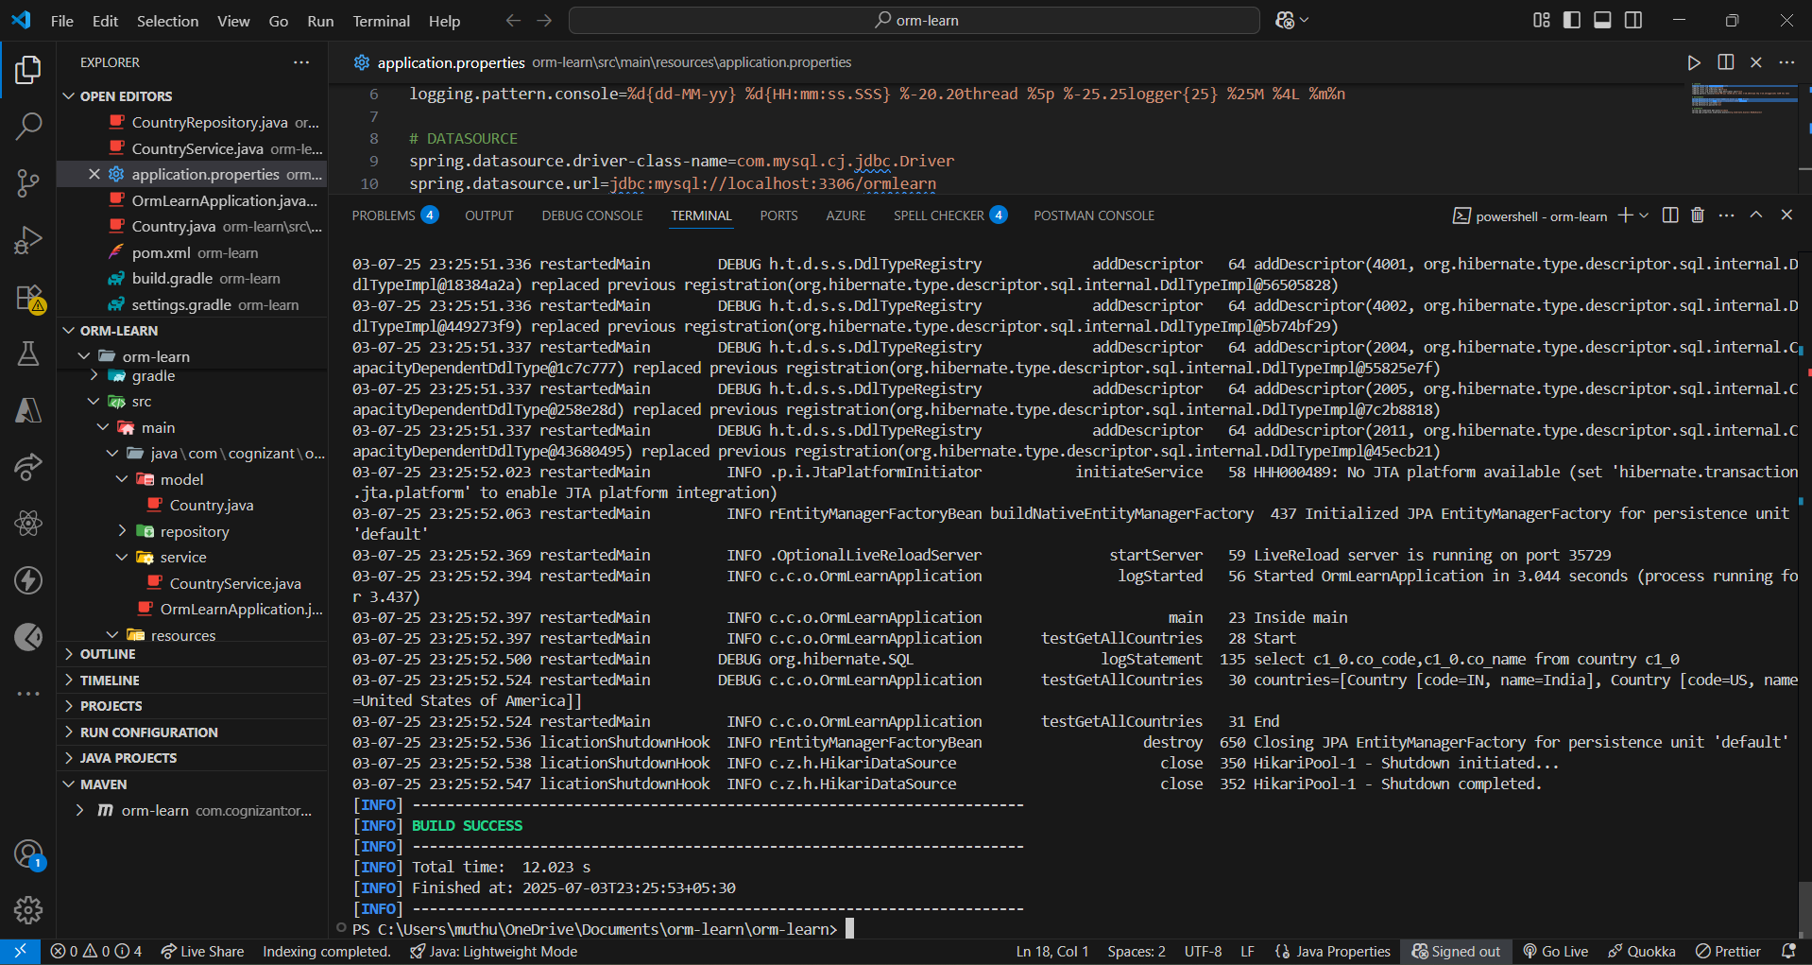

ii) Difference between JPA, Hibernate and Spring Data JPA:

public Integer addEmployee(Employee employee){

Session session = factory.openSession();

Transaction tx = null;

Integer employeeID = null;

try {

tx = session.beginTransaction();

employeeID = (Integer) session.save(employee);

tx.commit();

} catch (HibernateException e) {

if (tx != null) tx.rollback();

e.printStackTrace();

} finally {

session.close();

}

return employeeID;

}

EmployeeRepository.java

public interface EmployeeRepository extends JpaRepository<Employee, Integer> {

}

EmployeeService.java

@Autowired

private EmployeeRepository employeeRepository;

@Transactional

public void addEmployee(Employee employee) {

employeeRepository.save(employee);

}

Output:

